 | PERSONAL DATA FORM (PDF) | QP-244-F01

NELITO SYSTEMS LIMITED  Headquarters & Registered Office:  205-208 Bldg No 2, Sector 1, Millennium Business Park, Mahape, Navi Mumbai 400 710  Telephone: 2778 2646 Fax: 2778 2643  Site: www.nelito.com | ☺  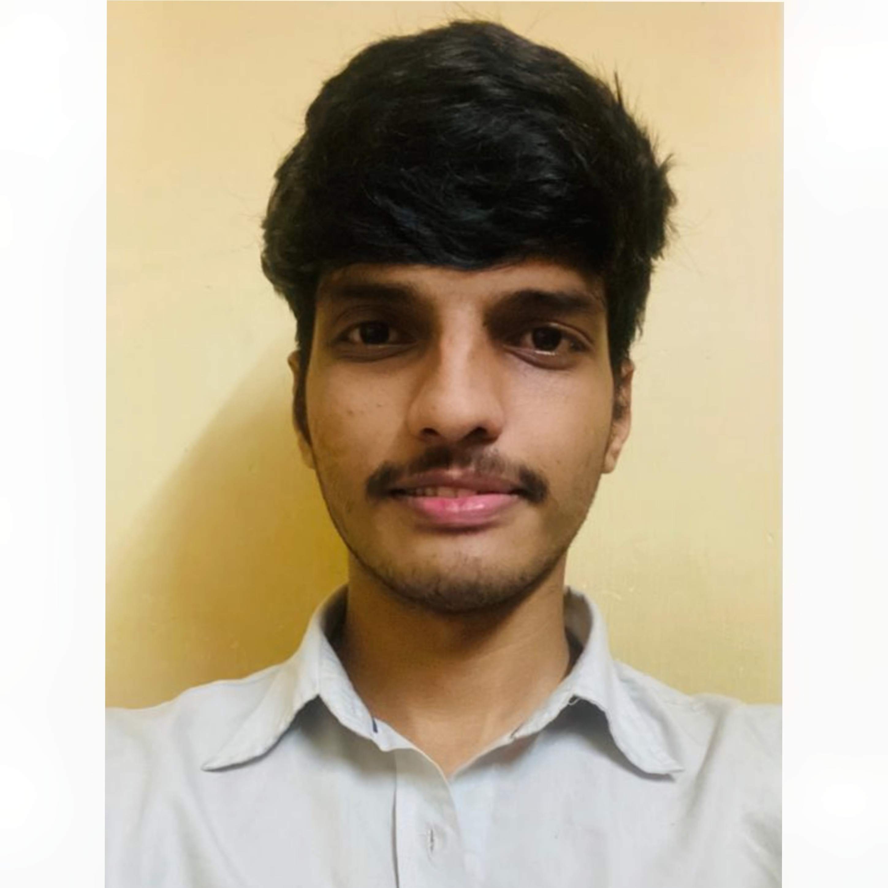  (Please paste your  Photograph here)

Reference (in case referred by a Nelito employee) |  | Date | 09-Mar-2026

Name | Middle Name | Surname
Abhijit | Suresh | Kolekar
(Note: Name in this Form should be the same as recorded on the PAN card & Other Documents)

Position Applied For | Full Stack .Net Developer

This form is intended to enable you to record important information about you as a person, your experience, your achievements & your plans for the future. Please use additional sheets, if necessary.

- Personal Data:
Date of Birth | 29-JUN-2000 |  |  | Marital Status | Married Unmarried
Address for Communication | Flat 302, Vitthal Residency Plot -306 |  |  | Permanent Address | Flat 302, Vitthal Residency Plot -306
 | Sector- R3, Vadghar |  |  |  | Sector- R3, Vadghar
 | Panvel |  |  |  | Panvel
 |  | 410206 |  |  |  | 410206
Mobile No | 9867450147 |  |  | Emergency Contact No | 9004938607
Alternate No | 9004938607 |  |  | E-mail Id | abhijitkolekar42@gmail.com
Aadhaar No | 667617458853 |  |  | Pan No. | HLMPK9713E

- Educational/Professional Qualifications:
Qualification | College/ Institute/ Board/ University | From | To | Marks %
X | Maharashtra State Board | 15-Jun-2015 | 01-Jun-2016 | 83.20
XII | Maharashtra State Board | 01-Aug-2017 | 01-Jun-2018 | 75.69%
Graduation  (Stream: ___EXTC___) | University of Mumbai | 01-Aug-2018 | 01-Aug-2022 | 80.10%
Post-Graduation  (Stream: _____________) |  | DD-MMM-YY | DD-MMM-YY
Certification (Specify if any)

- Experience: (including the Current Employment)
Company/ Organization | From | To | Position/Designation Held
Citiustech Healthcare Technology | 11-Jul-2022 | 23-Apr-2025 | Software Engineer
GEP | 28-Apr-2025 | DD-MMM-YY | Software Engineer
 | DD-MMM-YY | DD-MMM-YY
 | DD-MMM-YY | DD-MMM-YY

- Current/Last Employment:
Key Result Area / Responsibility |  | Achievement
- Packaging Concept in DMT |  | Independently worked on introducing packaging in DMT
Nature of Employment | On Contract Employment - Confirmed |  | Notice Period (Days)

- Family Details: (Note: DOB of family members are required for covering them under Medical Insurance)
 | Name | Education | Occupation | Age
Father | Suresh Pandurang Kolekar | FY Bsc | Mumbai Police (Retired) | 60
Mother | Indumati Suresh Kolekar | NA | HomeMaker | 50
Spouse
Children

- Your Strengths & Weaknesses:
Strengths | Weaknesses
Adapt Quickly | Multi-Tasking
Passionate | UnAssertive
Determination

- References: (Give two references under whom you have either worked/received education or who know you professionally)
Name | Shreedhar Patkar | Kaleemulllah Shaikh
Designation | Technical Lead | Senior Principal Software Engineer
Organisation | CitiusTech | GEP
Contact No(s) | 9967978225 | 9029607271
E-mail ID | NA | NA

Declaration: I hereby authorize verification of all statements in this form and agree to produce any documentary evidence in proof of above statements, as desired by Nelito. I certify that all the above statements are true and I understand that misrepresentation or omission of facts called for in this form can be a cause of termination of my services from the Company. If employed, I also agree to abide by all the rules and regulations, code of conduct, etc. of the Company.

Place: Navi Mumbai Signature __________________________________
Date: 09-Mar-2026

